Inventory Management
&
Customer Billing System



Student Name: Dipika Anand
Reg. No.: 25BCE10703
Subject: CSE1021 INTRODUCTION TO PROBLEM SOLVING
College: Vellore Institute of Technology BHOPAL
Year: 2025
Submitted To: Dr. Lakshmi D
Slot: A21+A22+A23
Introduction

This project is a Python-based Inventory Management and Customer Billing System developed using MySQL as the backend database. The system automates stock handling, updates product quantities, generates customer bills, and ensures smooth retail operations. It eliminates manual bookkeeping and provides accurate, real-time record management.

Problem Statement

Many retail shops and small businesses still maintain stock manually, which causes errors in quantity tracking and billing. There is a need for a simple, fast, and efficient computerized system to: Maintain product stock, Update items after purchase, Generate correct bills, Reduce human error.
This project solves these problems through a structured, database-driven application.
Functional Requirements

The system performs the following functions:

Stock Module
1. Display all stock items
2. Add new stock items
3. Delete an existing item
4. Modify/update a stock item
5. Display details of a single item

Billing Module
1. Search stock from database
2. Verify available quantity
3. Generate bill for customer
4. Update stock after billing
5. Save bill details into bill.csv

Non-Functional Requirements

1. Usability: User-friendly menu-driven interface via console.
2. Performance: Fetches and updates stock within milliseconds using MySQL.
3. Reliability: All operations are database-committed to ensure accuracy.
4. Maintainability: Code is modular—stock() and billing() modules separated.
5. Security: Database connection protected by MySQL credentials.
6. Error Handling: Handles invalid input, missing items, and insufficient stock.

System Architecture

Architecture Layers:
1. User Interface: Python CLI
2. Application Logic:
Stock maintenance module
Billing module
3. Database Layer: MySQL stock table
4. File Storage: bill.csv
Flow:
User → Python Program → MySQL Database → Updated Stock → Bill Generated

Design Diagrams
a. Use Case Diagram
Manage Stock
Add/Modify/Delete Item
Generate Bill
Update Stock
Save Bill
b. Workflow Diagram
Start
↓
Main Menu
↓
[1] Stock Module → Display/Add/Delete/Modify
↓
[2] Billing Module → Select Item → Check Qty → Calculate Bill → Update Stock → Save CSV
↓
Exit
c. Sequence Diagram (Billing Example)
User → System: Enter item_no
System → DB: fetch item
DB → System: return item
User → System: enter qty
System → System: calculate total
System → DB: update stock
System → CSV: write bill
System → User: display bill

d. Class/Component Diagram

Components:
get_db_connection()
stock()
billing()
MySQL stock table
bill.csv file
e. ER Diagram
Table: STOCK
item_no
item_name
quantity
unit_price

Design Decisions & Rationale

MySQL chosen for reliability and persistent storage.
CSV used for bills because it is portable and readable in Excel.
Modular functions used to improve maintainability.
Loop-based UI ensures repeated operations without restarting the program.

Implementation Details

Python used for main program.
mysql.connector used for DB interactions.
Menu-driven console interface.
Exception handling for invalid inputs.
Auto-update of stock after billing.
bill.csv generated with multiple entries (customer_name, item_no, name, qty, unit_price, total).

Results

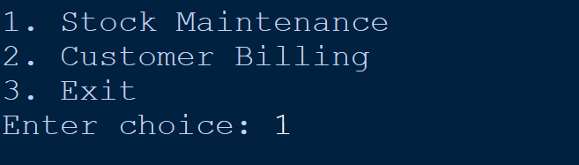
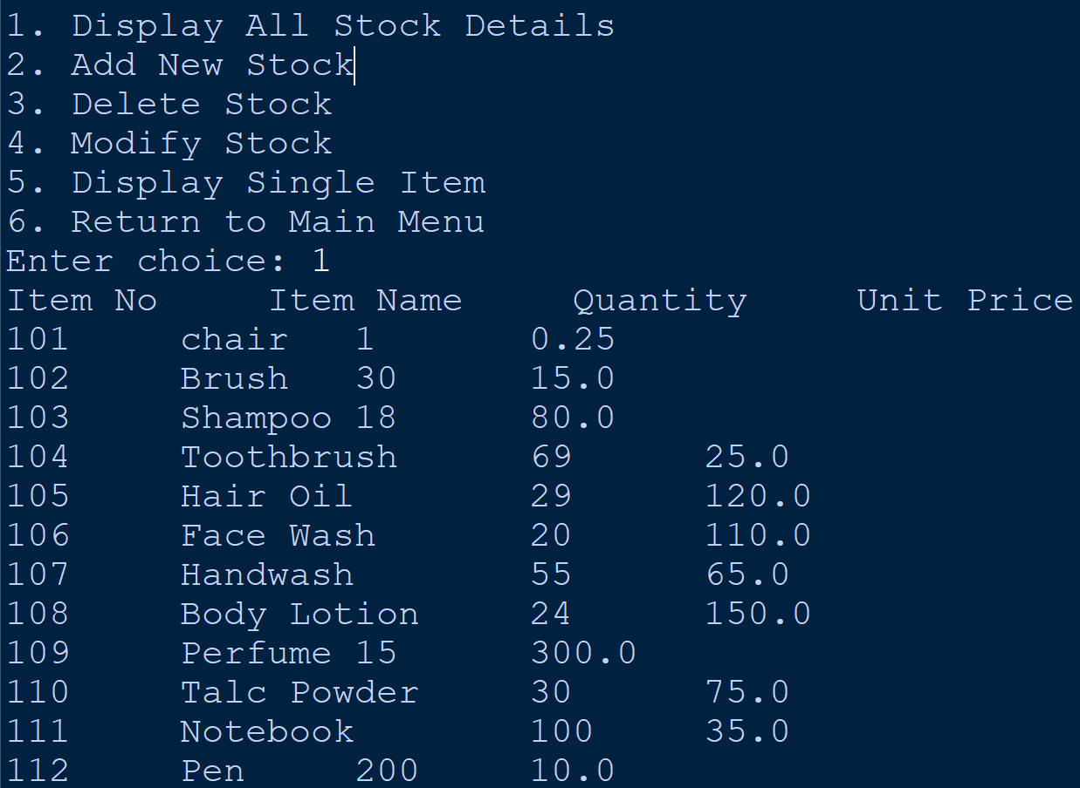
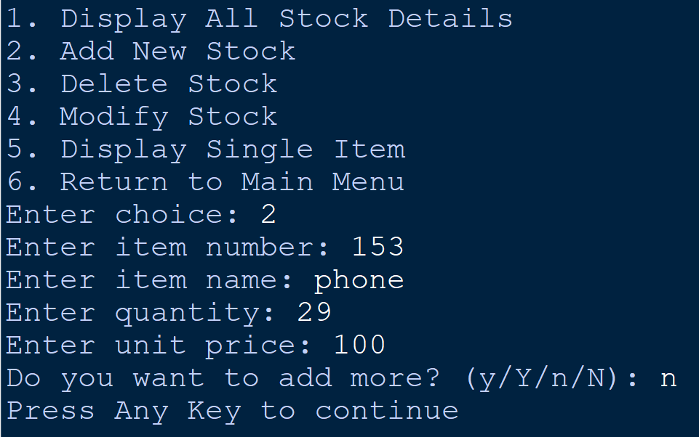
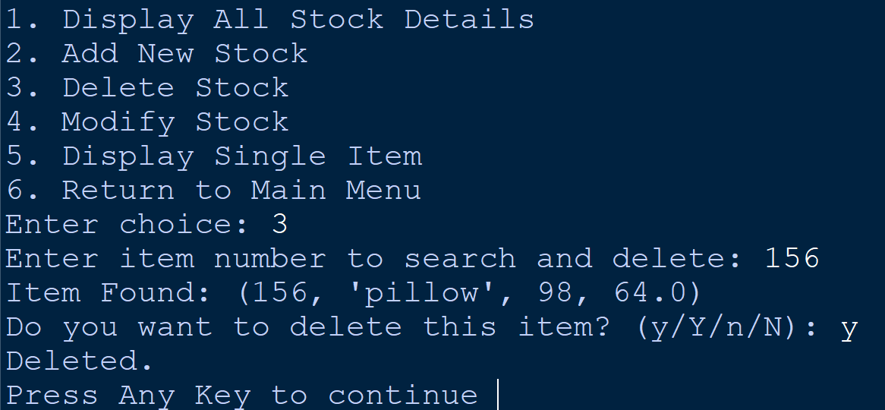
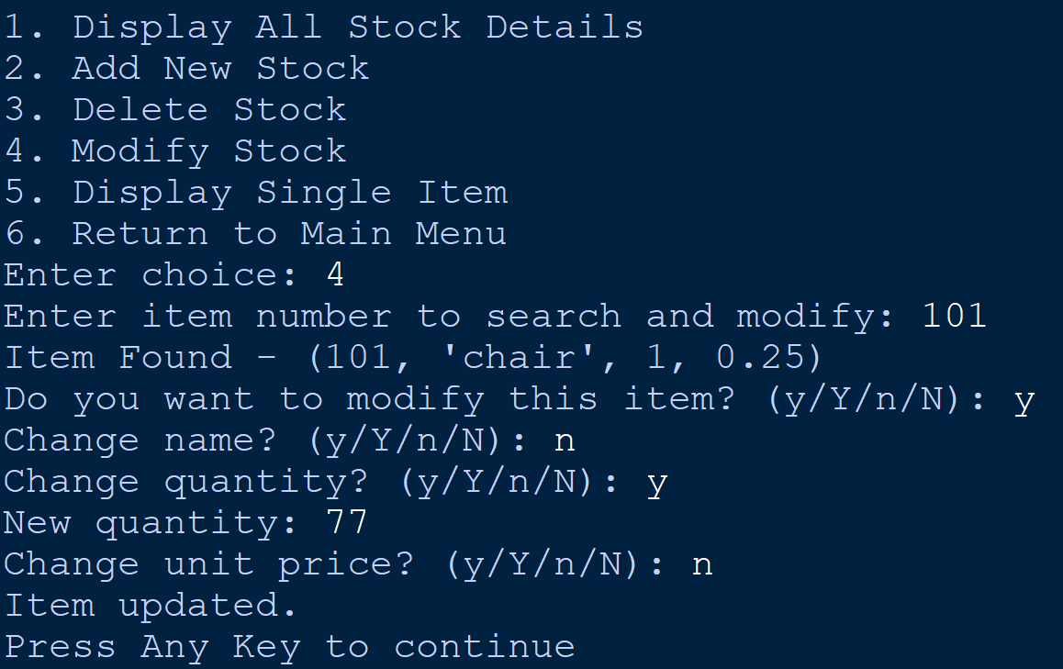
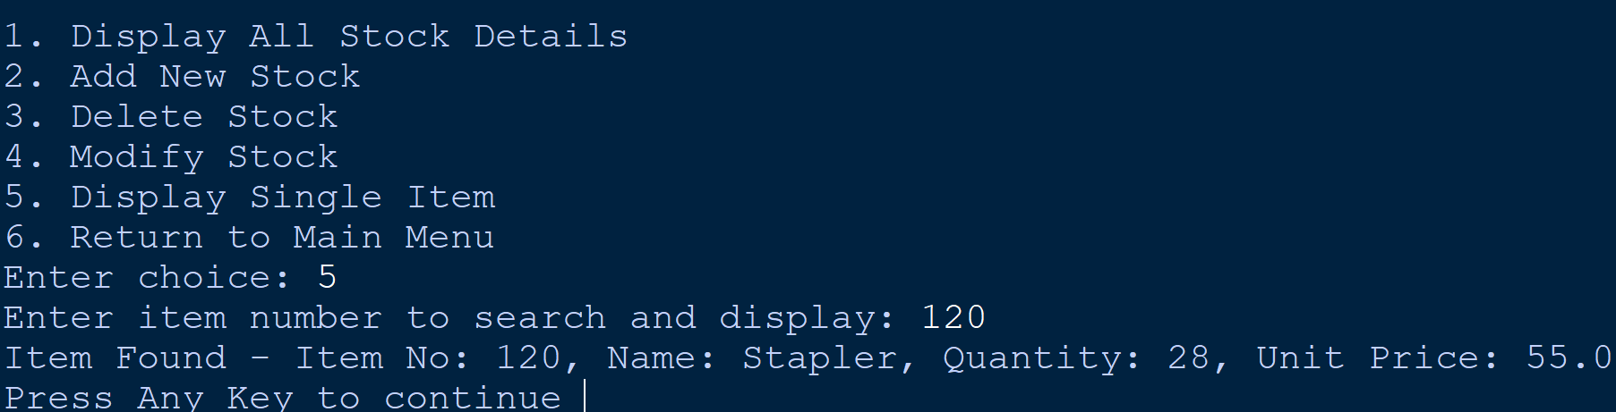
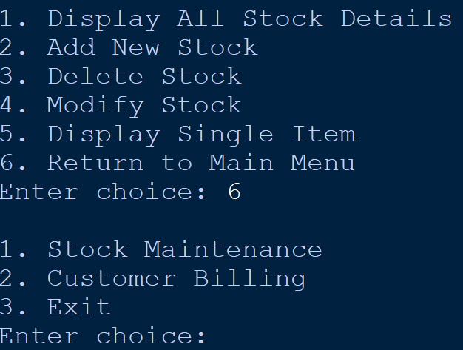
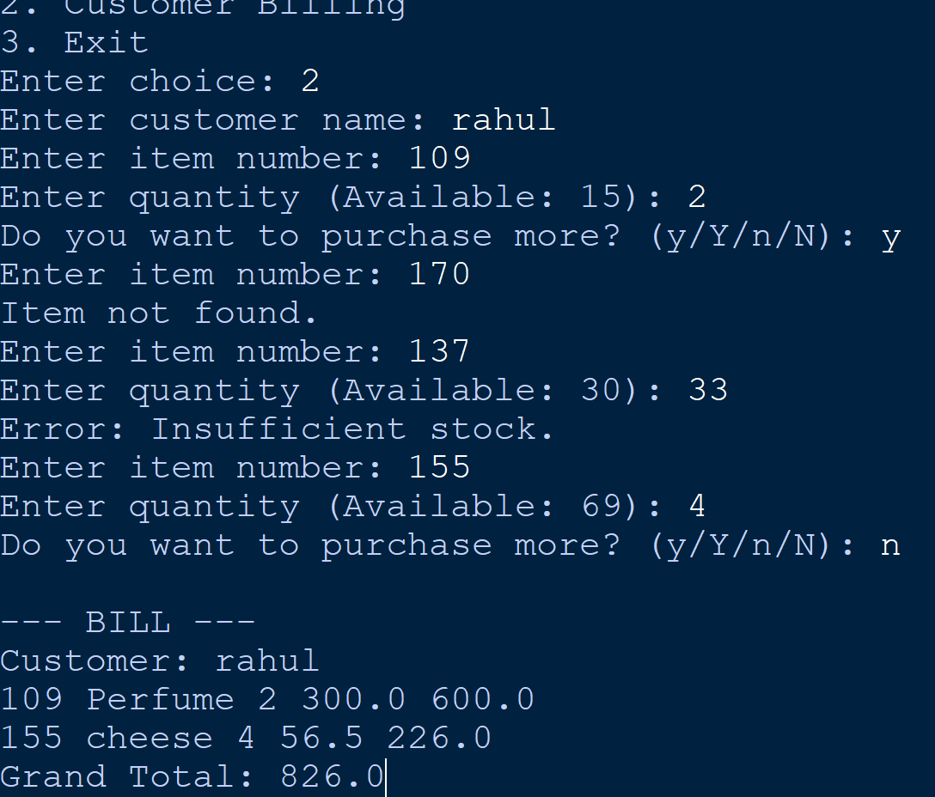
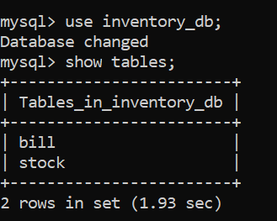
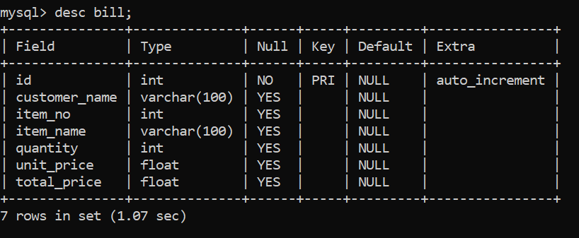
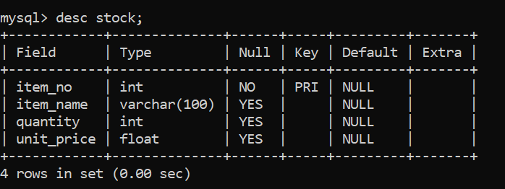
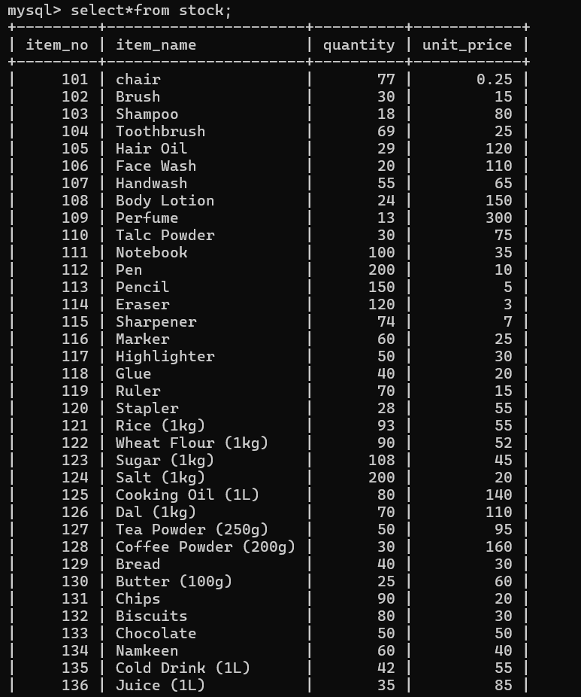

Testing Approach

Test Cases Included:
1. Add stock with valid/invalid values
2. Delete item not present
3. Billing with insufficient stock
4. Billing with correct quantities
5. Checking bill.csv after multiple purchases

All test cases passed successfully.

Challenges Faced

Maintaining synchronization between stock table and bill updates
Handling invalid input formats
Ensuring bill.csv writes multiple rows correctly
Avoiding crash when incorrect item number entered

Learnings & Key Takeaways

Understanding MySQL–Python integration
Implementing CRUD operations
File handling using CSV module
Error handling and modular programming
Real-world problem-solving through coding

